

|  |  |  |
| --- | --- | --- |
| BATCH | ENROLLMENT NUMBER | STUDENT NAME |
| B2 | 18103085 | Sudeep Srivastava |
| B7 | 18103236 | Suryansh Singh |
| B9 | 18103281 | Nikhil Chandna |

**Supervisor - Dr. Suma Dawn**

**Minor Project -2**

**Title: WebHealth**

**Computer Science Engineering**

**DEPARTMENT OF COMPUTER SCIENCE ENGINEERING & INFORMATION TECHNOLOGY**

**JAYPEE INSTITUTE OF INFORMATION TECHNOLOGY, NOIDA**

# **Summary Sheet**

## **1. Motivation behind the project**

In this hectic world Our Personal health gets really messed up therefore as a responsible human we should take care of our body in full earnest .Hence we are developing a project in which we are building a website which will help people to take off their health physically and help them drive towards their goal.

## **2. Type of project**

a. Pure development project

We are making a fully functional as well as Responsive Website using MERN Stack.

## **3. Analysis of research paper**

a-**Thomas, Michael H., and Steve P. Burns. "Increasing lean mass and strength: A comparison of high frequency strength training to lower frequency strength training." *International journal of exercise science* 9.2 (2016): 159.**

Through this Research Paper we came to the conclusion of which type of exercise is best for People who wanna improve their lean mass , muscle strength and bulking.

b- **Boutcher, Stephen H. "High-intensity intermittent exercise and fat loss." *Journal of obesity* 2011 (2011).**

Through this one we came to the conclusion of How HIIE is best for people who wanna lose fat.

To calculate Calorie Requirement for a person we have used this formula-

**Harris-Benedict formula.**

**Formula used to calculate men’s calorie needs is = 66.5 + 13.8 x (body weight in kilograms) + 5 x (body height in cm) divided by 6.8 x age. Meanwhile for women= 655.1 + 9.6 x (body weight in kilograms) + 1.9 x (body height in cm) divided by 4.7 x age.**

## **4. Design Diagram**

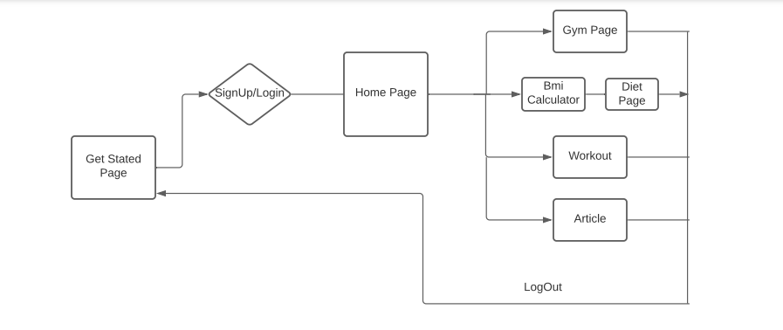

## **5. Features built, language used**

Languages Used: JS, HTML, CSS

Technologies used: MERN Stack

## **6. Algorithm/Description of the Work**

Our website is a complete solution for a person who wanna enhance their physical health.

**HOMEPAGE-**

The user is greeted with a Responsive homepage with access to the login page as well as a video explaining them about our website .

**SIGN-UP/LOG-IN**

A user then logins or signups into the system with a username/email and password which is stored in the MongoDB Database.

**WELCOME PAGE**

User is redirected to a welcome page where there is a chatbot along with a sidebar and all the sub-links connected to different pages.User can see their name on the top right corner depicting that they have logged in.

**CHATBOT**

We have used an API called Kommunicate which is an AI-Powered and trainable bot along with the ability to connect users to a human agent.

**SIDEBAR**

Through Sidebar a user can navigate through different pages on our website as per their requirement.

**GYM**

Through the Gym link user can visit and see different gyms in their area as well as can see various details of gym or track their location on Google map

**WORKOUT**

First we will understand a user’s needs and then suggest them workouts according to their needs.

A user needs to input their gender, age,and what they wanna achieve and with the help of various research papers we studied we will suggest them the best routine to follow for their health.

**BMI CALCULATOR AND DIETS-**

A user needs to enter their age ,gender , physical activity,height and weight with which we will calculate BMI using the standard formula -

**BMI= (weight)/(height*height)**

And then depending if the user wanna see the best suggested diet for them we will ask them to continue and suggest the best diet according to their calorie needs by using **Harris-Benedict formula.**

**Formula used to calculate men’s calorie needs is = 66.5 + 13.8 x (body weight in kilograms) + 5 x (body height in cm) divided by 6.8 x age. Meanwhile for women= 655.1 + 9.6 x (body weight in kilograms) + 1.9 x (body height in cm) divided by 4.7 x age.**

**ARTICLE-**

A user will see various articles that we have linked through guiding them to the various websites where we can read the Article as well as a newsletter and subscribe to the website.

## **7. Division of the work among students**

### **Nikhil:**

Back-end and Front-end

**Sudeep:**

Front-end and research paper analysis

**Suryansh:**

Front-end and research paper analysis

## **8. Results and Conclusion**

Our website successfully recommends an appropriate caloric diet as well as suggest a good workout routine along with local nearby places where they can go exercise. Also, an assisted chatbot is added to guide them.